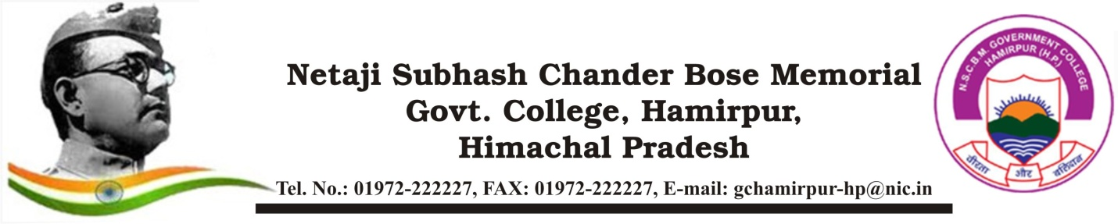

**Report**

**Title: Selection of Students for " Initiation into Mathematics" Program@NIT Hamirpur**

Six students of B.Sc. 2nd year from the Department of Mathematics, Netaji Subhash Chandra Bose Memorial Government College, Hamirpur, Himachal Pradesh have been selected to attend the " Initiation into Mathematics" (InitMath) program, scheduled to take place at NIT Hamirpur from September 16th to 21st, 2024. This program is funded by National Board of Higher Mathematics (NBHM), DST, GoI.

These students are selected on the basis of good academic record and recommendation by the concerned teacher.

Notably, student Rachna Thakur has been selected based on her outstanding performance in the Online Foundation Course in Mathematics (OFCM)2024) , a National level program organized by the MTTS Trust w.e.f August 18th to 31st, 2024.

The selection of these students is a testament to their academic excellence and potential in mathematics. The "Initiation into Mathematics" (InitMath HP) program aims to provide a platform for young talent to explore and enhance their mathematical skills, and we are confident that our students will greatly benefit from this opportunity.

We congratulate the selected students and wish them all the best for their participation in the program.

Selected Students:

1. Rachna Thakur

2. Mahak

3. Monika

4. Ashmita

5. Abhay Jaswal

6. Ansh Chopra